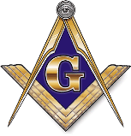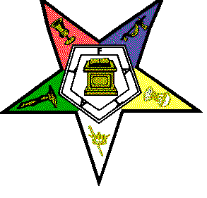Mecca Grand Lodge & Heroines of Jordan Grand Chapter
Schedule of Events: Grand Council Session 2016
DATE/TIME | EVENT | DRESS
Wednesday 8/31/2016
7:00pm-9:00pm | Grand Chapter /Workshop | Regalia
7:00pm-9:00pm | Mecca Grand Lodge Workshop | Regalia
Thursday 9/1/2016
10:00am-5:00pm | Registration | Casual
7:00pm-9:00pm | Grand Opening Ceremony/Memorial | Business
9:30pm-12:00am | Welcome Reception/Fellowship | Casual
Friday 9/2/2016
10:00am-5:00pm | Registration
12:00pm-2:00pm | Grand Lodge Meeting | Regalia
12:00pm -2:00pm | Grand Chapter Meeting | Regalia
9:00pm-1:00am | Fellowship Dance ( Rep your Lodge/ Chapter T-shirt) | Casual
Saturday 9/3/2016
8:30am-12:00pm | Seating/Deliberation of the Council | Regalia
1:30pm-3:30pm | Elections /Grand Lodge & Grand Chapter | Regalia
7:00pm-1:00am | Awards Banquet & Ball ( Black & Gold) | Formal
Sunday 9/4/2016
3:00pm-5:00pm | Church Service | Regalia
6:00pm-8:00pm | Reception | Regalia

